Calculation of the Input resistance of a Triode with a complex plate load.
By Felix A. Schaffhauser

Abstract
A tuned triode amplifier is prone to oscillations due to the tube inherent grid-plate capacitance. This “Miller”-capacitance transforms the plate impedance into an input impedance at the grid. If the load is inductive, this input impedance has a negative resistive component and can therefore compensate the losses of the input tank and associated antenne circuitry.
In the case of a pure amplifier oscillations are unwanted and this feedback needs to be compensated (neutralized), but in other cases like an audion detector regenerative feedback is desired for increasing the resonant impedance and the selectivity of the input tank.
To understand better the relationship between the plate load impedance and the negative input resistance achieved at the grid a simple formula is derived, which can easily be implemented on a graphics calculator like e.g. the Hp 48, the TI-8x series or on a PC running MathCAD or similar program. This allows “playing” with the parameter values and immediately see the effect it has on the input resistance.

Approach
As a practical example the Armstrong regenerative audion as patented in US Pat. Nr. 1,113,149 Oct.6, 1914 is used as shown in fig.1. The schematic is slightly simplified to the essentials.
The losses of the inductors are converted into parallel-resistors of the respective tank circuits.
The series resistors $R_{v}$ of the inductors can be converted into parallel resistors of the tank circuit with the following formula: $R=\frac{L}{R_{v}⋅C}$

The grid resistor is also combined into this resistor as well as the resistance of the antenna coupling circuitry. It is this resulting resistor that we want to compensate with a negative input resistance.
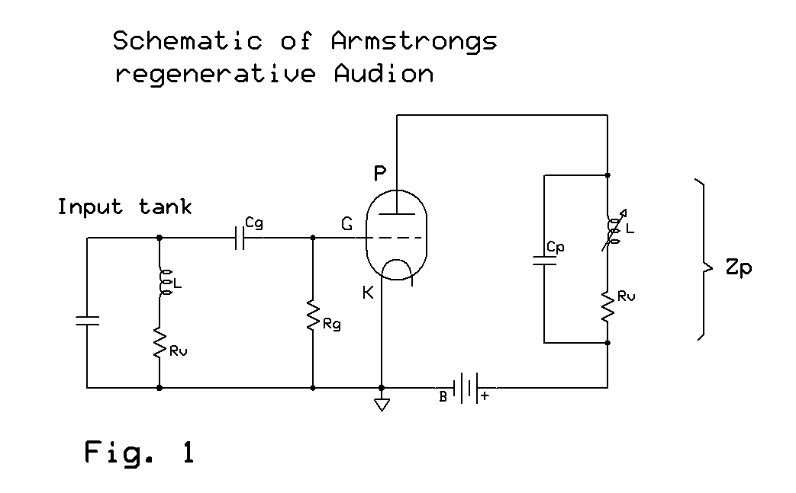
The input impedance of the triode is dependant on the amplification ($A$). Using the AC equivalent circuit of the triode in fig. 2 we will derive the AC-amplification. The plate load impedance $Z_{p}$ will be replaced by its inverse, the admittance$Y_{p}$.
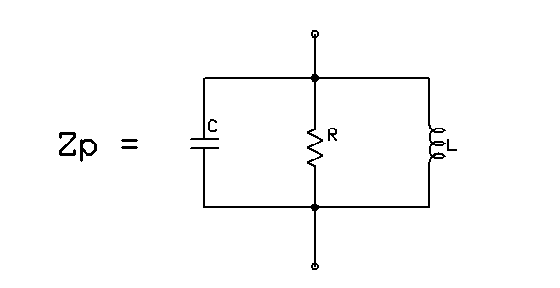
$Y_{p}=\frac{1}{Z_{p}}=\frac{1}{jωL}+jωC+\frac{1}{R}=\frac{1}{R}+j\left(ωC−\frac{1}{ωL}\right)$

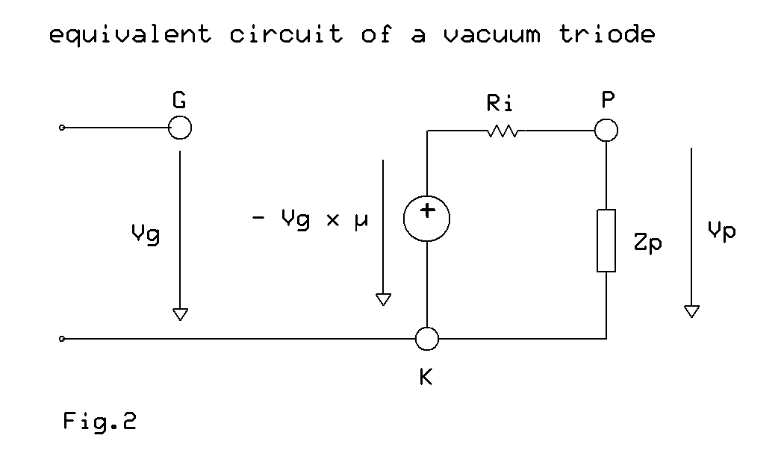

$A=\frac{V_{p}}{V_{g}}=\frac{1}{V_{g}}⋅\frac{−V_{g}⋅μ}{R_{i}+Z_{p}}⋅Z_{p}=−\frac{μ}{1+\frac{R_{i}}{Z_{p}}}=−\frac{μ}{1+R_{i}⋅Y_{p}}=−\frac{μ}{1+\frac{R_{i}}{R}+{\text{jR}}_{i}\left(ωC−\frac{1}{ωL}\right)}$ [eq. 1]
The amplification ($A$) is complex due to the complex plate load. The negative sign is essential and is the result of the fact that the plate $V_{p}$voltage has a phase shift of 180 degrees with respect to the grid voltage $\text{Vg}$. The following parameters are characteristics of the older triode tubes:

$μ=$ amplification factor of the triode ( approx. = 10)
$R_{i}=$ internal plate resistance (approx. = 10kOhms)

The calculation of the input impedance (or admittance $Y_{\text{in}}$resp.) of the triode follows by resolving the node equation at the grid ($G$) and the plate loop.
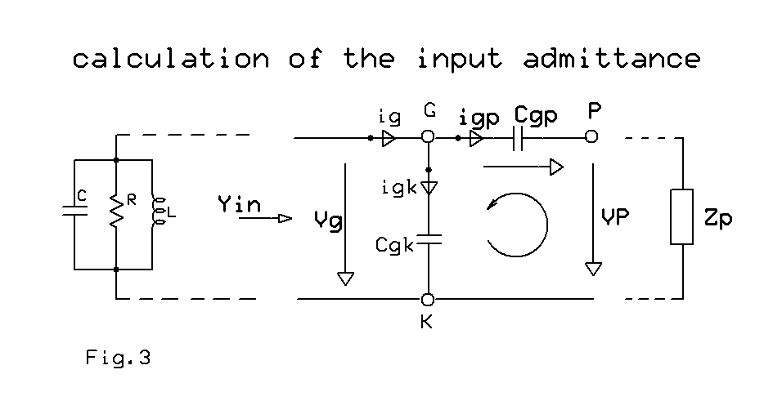
$$i_{\text{gk}}=V_{g}⋅{jωC}_{\text{gk}}$$
$V_{g}−V_{p}−i_{\text{gp}}⋅\frac{1}{{jωC}_{\text{gp}}}=0$ $i_{\text{gp}}={jωC}_{\text{gp}}\left(V_{g}−V_{p}\right)$
$i_{\text{gp}}={jωC}_{\text{gp}}\left(V_{g}−A⋅V_{g_{{}_{g}}}\right)={jωC}_{\text{gp}}V_{g}\left(1−A\right)$
→ $Y_{\text{in}}=\frac{i_{g}}{V_{g}}=\frac{i_{\text{gk}}}{V_{g}}+\frac{i_{\text{gp}}}{V_{g}}={jωC}_{\text{gk}}+{jωC}_{\text{gp}}\left(1−A\right)$ [eq.2]

The Input admittance consists of a capacitance $C_{\text{gk}}+C_{\text{gp}}$ and a complex element
$$−{jωC}_{\text{gp}}⋅A$$
The capacitive part just adds to the capacitance of the input tank and lowers its resonant frequency. ( The same is also true for the capacitance plate-cathode ($\text{Cpk}$), which was not taken into consideration so far; it adds to the capacitive part of the plate impedance).

It’s the resistive component we are interested in:

If we multiply $−{jωC}_{\text{gp}}$ by the imaginary part ($j⋅$Im) of the amplification ($A$) we get the resistive component of the input admittance. Starting with

$A=−\frac{μ}{1+\frac{R_{i}}{R}+{\text{jR}}_{i}\left(ωC−\frac{1}{ωL}\right)}=−μ\frac{1+\frac{R_{i}}{R}−{\text{jR}}_{i}\left(ωC−\frac{1}{ωL}\right)}{{\left(1+\frac{R_{i}}{R}\right)}^{2}+R_{i}^{2}{\left(ωC−\frac{1}{ωL}\right)}^{2}}=\text{Re}+j⋅\text{Im}$ [eq.3]

where Re = real part and Im = imaginary part of the complex expression.

Im = $\frac{μ⋅R_{i}\left(ωC−\frac{1}{ωL}\right)}{{\left(1+\frac{R_{i}}{R}\right)}^{2}+R_{i^{2}}^{2}{\left(ωC−\frac{1}{ωL}\right)}^{2}}$

Thus multiplying the imaginary components in [eq.2] and [eq.3] $−{jωC}_{\text{gp}}⋅j$Im

yields $Y_{\text{in}}=\frac{{μR}_{i}{ωC}_{\text{gp}}\left(ωC−\frac{1}{ωL}\right)}{{\left(1+\frac{R_{i}}{R}\right)}^{2}+R_{i}^{2}{\left(ωC−\frac{1}{ωL}\right)}^{2}}$ [eq. 4]
This is a conductance that can be negative, if $ωC≤\frac{1}{ωL}$ i.e. the plate impedance has to be inductive, which is the case when the resonant circuit is operated below its resonant frequency. In a practical radio this inductor needs to be adjusted very carefully. That’s why Armstrong uses a variable inductor in the plate circuit.

The above formula [eq. 4] can be entered into a graphics calculator with all the parameters as independent variables or it can be simplified further using practical values for the tubes values$μ, R_{i}, C_{\text{gp}}$ and $R$.

In the following example $μ$ = 10
$R_{i}$ = 10kOhms
$R$ = 3.6 MOhm and
$C_{\text{gp}}=5$pF
are used
Inserting these values, eliminating $\frac{R_{i}}{R}$ (as $R_{i}$ << $R$) and substituting the term $\left(ωC−\frac{1}{ωL}\right)$ for simplicity gives

$Y_{\text{in}}=\frac{0\text{.}5⋅{\text{10}}^{−6}⋅ω⋅Y_{\text{LC}}}{1+{\text{10}}^{8}⋅Y_{\text{LC}}^{2}}$ where $Y_{\text{LC}}=\left(ωC−\frac{1}{ωL}\right)$ eqs. [5,6]
The expressions on the right side can directly be typed into the caculator Hp 48 SX using the equation function. They will get named $Y_{\text{in}}$and$Yalignl{\begin{aligned}\text{LC}\end{aligned}}_{}$ respectively.
With the “plot “ function $ω$ is defined as the independant variable with a range of
Xmin = 3500000 (for f = 557kHz) and Xmax = 8500000 (for f = 1352kHz) and the other variables $L$ und $C$ are chosen such as to get the desired resonant frequency.
In the example shown below the values for the plate tank are chosen as follows:

$$\begin{aligned}L=\text{500}μH \\ C=\text{62}\text{pF} \\ f_{\text{res}}≈\text{904}\text{kHz}\end{aligned}$$

Result: In fig.4 which is a screenshot of the resulting diplay of the plot-function there is a second curve shown (the monotonically descending curve). This is the $Y_{L}$ for a pure inductive plate load for comparison. In [eqs. 5,6] $C$ is set to zero: → $Y_{L}=\frac{−0\text{.}5⋅{\text{10}}^{−6}}{L\left[1+{\left(\frac{{\text{10}}^{4}}{ωL}\right)}^{2}\right]}$

This 2nd equation is added in the plot mode using the “CAT “ and “EQ+” .

The “coordinate” function allows to move the cursor-cross around and see the values of $ω$ and $Y_{\text{in}},Y_{L}$ respectively in [mhos] at the bottom of the display. The cross is set at the neg. maximum to display the maximum negative admittance (minimal negative resistance for regeneration) achieved.
It should be easy to use a similar approach when programming a TI-85 to -89 calculator
Or any other graphics calculator.

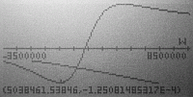
Fig.4

The maximum negative admittance being $\overset{}{Y_{\text{in}}}=−1\text{.}\text{25}⋅{\text{10}}^{−4}\text{mhos}$ occurring at a frequency of 801 kHz. This would allow theoretically to compensate for an input loss resistance of > 8kOhms. In practice (for getting a smoother regeneration control) one would operate with these plate load values at e.g. 650kHz input frequency therby sacrifying some negative resistance for compensation.
The plot function of the Hp 48 can easily be used to change various parameters and directly investigate the effect on the final input admittance. Knowing the loss resistance of the input circuitry allows to define the frequency range for which regeneration is possible and hence to give possible values for the plate load. It can be seen, that a resonant circuit in the plate has advantages above a pure (practically anyway not possible) inductor. But this needs careful adjustment. For choosing the right regeneration amount for maximum sensitivity and selection it is advisable to tune the plate circuit high enough in order to operate below this neg. maximum of the admittance. This allows for a smoother adjustement of the regeneration.
The same program with similar thoughts can obviously also be used for answering neutralization questions in tuned amplifier stages. Here the question is where to operate the triode tube in order to avoid (at least too much) negative input admittance.

