Christian ADAM Rmorg the 28th of Sept 2008

DISCOVERING AN IBM COMPUTER SUB ASSEMBLY

I received in September a gift from a friend who was very active in our French CHCR old radios collector club. He died several days after. His name is Jean LE GALUDEC. I was very interested to know more about this sub assembly.
Fortunately I could remember a forum on Radiomuseum.org showing an equivalent device. The German forum title was “Unbekannte Baugruppe mit ECC92”.

- IDENTIFICATION OF THE TUBE

No marking could be read on the tube. So I decided to put photos on this forum, after an advertising from IBM showing this kind of device as an elementary component for computers.
Thanks to our colleagues Bernhard NAGEL and Jacob ROSCHY the tube could be identified as an heptode. Especially the number 6B3001 could be read on the top of the tube as shown on photo, making sure it is a 1680 tube identified by it’s IBM code “6B3001”:

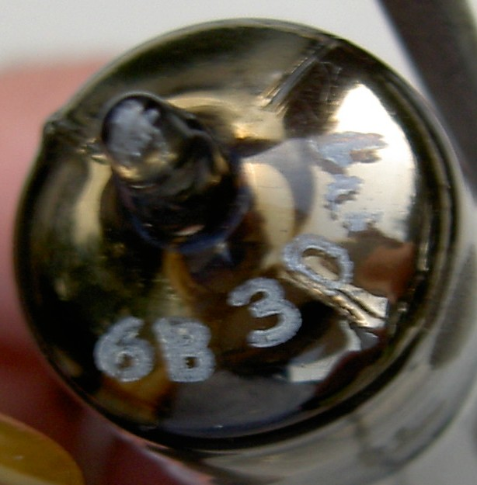

- IDENTIFICATION OF THE FUNCTION OF THE SUB ASSEMBLY

The 1680 tube is a 7 pin Miniature base, but the assembly is set on a Noval base.
Here the Miniature base of the 1680:

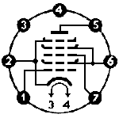

First I made the schematic of the sub assembly:
To understand how it works and to get values for applied voltages, the best was to search on Radiomuseum.org. For example here the schematic given on the equivalent E91H page to get an AND gate:

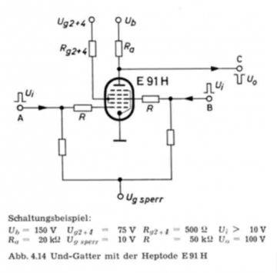
Both schematics are very close, with roughly the same resistors values. But in our case we have 4 additional components C1, C2, R3 and R4.
By comparison I could deduce:

Plate voltage (N3) = 150V
Screen voltage (N5) = 75V
Negative polarisation (N8) = -10V

Obvious also was that N4 is the output and N7 and N9 the two gate inputs. Analysing the Radiomuseum.org data sheet for the E91H (thanks to Roy Johnson), I could confirm that having both inputs (grids g1 and g3) at negative 10V is the non conducting state for the tube. Same when one of the gate g1 or g2 is driven to 0V. But with both g1 AND g3 at 0V, the conducting stage is reached and anode current should be > 5,5 and < 7,0 mA.

A simple calculation showed that because of the dividing resistors (R3/R5) and (R4/R6) this 0V grid condition drives to both inputs N7 and N9 connected to 8V positive.

- TESTING OF THIS “AND GATE” SUB ASSEMBLY

I wanted to see this elementary AND gate in action. To check this I introduced 2 push buttons and a LED in the anode circuit (less then 2V voltage drop) as given in the test schematic. Heater is fed under DC 6,3V because of the internal connection to the cathode. Here the construction I made:

Measurements:

When both push buttons are activated :

LED is ON and plate current is 5,4 mA close to the mini value of 5,5 mA
Screen g2 and g4 current is 8,1 mA
Output varies from 150V to 45V (105V drop to be compared to the U0 = 100V indicated by the German “and gate” with E91H)

It’s really an AND gate!

