MODEL 56TP | TUBE LAYOUT
POWER RATING  117 VOLTS AC  60 CYC. 35 WATTS  20 WATTS ADD.  FOR PHONO MOTOR | 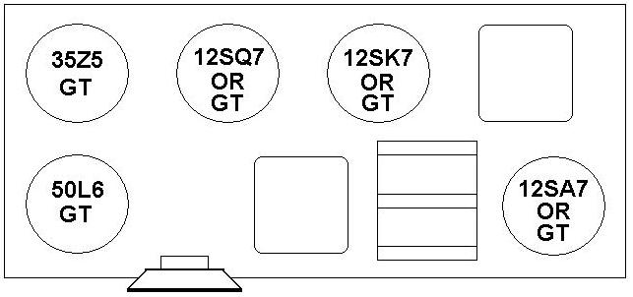
THE CROSLEY CORPORATION
CINCINATTI, OHIO
PRINTED IN U.S.A. FORM No. W-134749C

